TYBCA
SEMESTER – V
Advanced Python
Date : 06/08/2021
Assignment - 4
- Create one Book class that contains constructor with no of pages in book.
  - Now create four objects for Book.
  - Display total no of pages available within this four books.
- Create one student class that contains name and marks of students.
  - Now create two objects for student class like student1 and student2 and check whose marks are greater by overloading ‘>’ Operator.
- Composition:
Example 1 :
class Department:
a=10
def __init__(self):
self.b=20
def m1(self):
print("Department class method...")

class MSU:
def __init__(self):
self.department = Department()
def m2(self):
print("Msu has a department...")
print(self.department.a)
print(self.department.b)
self.department.m1()

m = MSU()
m.m2()
- Create a class Engine that have a as static variable, b as instance variable and m1() as instance method.m1() display message that “This is Engine class method….”
Now create one more class named Car that has one instance variable as engine that references Engine class and m2() instance method that can use all the variables and method of engine class.
Now create a Car class object and call m2() method.
- Create a class car that have name ,model and color as variables and getinfo() method that display all information of car.
Now create one more class Employee which have emp_name,emp_no and car(Which is reference of car class) and empinfo() method that display all information about employee including his car details.
- Inheritance :
class Parent:
def m1(self):
print("Parent class method...")
class Child(Parent):
def m2(self):
print("Child class method...")

p = Parent()
p.m1()
#p.m2() # error Parent class can’t access child class method
c = Child()
c.m1()
c.m2()
- Create a class Peson that have name and age as variables and eatanddrink() that display message “Eat biryani and Drink coca cola”.
Now create a child class Employee that has name,age [deriverd from super class],emp_no,emp_salary as variables and empinfo() that display all information of employee.
Now try to call each class methods.
- Design Following Application using tkinter.when you click on place order button total bill will be displayed on messagebox.
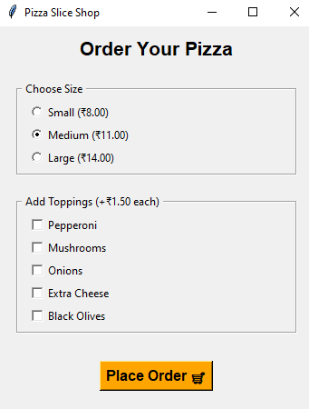
- Design calculator using tkinter.

